Software Requirements Specification

for

ONLINE ELECTRIC CAR PURCHASER SOFTWARE SYSTEM

Prepared by: Hina Babur 3157

Nimrah Yousuf 3178

Maryam Musaddiq 3183

International Islamic University

4th January, 2018.

Contents

1. INTRODUCTION 2

1.1BACKGROUND 2

1.2PURPOSE 2

1.3SCOPE 3

1.4FUCTIONAL REQUIREMENTS 3

1.5NON-FUNCTIONAL REQUIREMENTS 5

1.6 WORK BREAKDOWN STRUCTURE (WBS) 6

1.7 ACTIVITY GRAPH 8

1.8 CRITICAL PATH 9

1.9 GANTT CHART 11

1.10 CONTEXT LEVEL DATA FLOW DIAGRAM 11

01.11 DATA FLOW DIAGRAM 12

1.12 ERD 13

1.13 USE CASE DIAGRAM 14

1.14 SYSTEM SEQUENCE DIAGRAM 15

1.15 SEQUENCE DIAGRAM 1 16

1.16 SEQUENCE DIAGRAM 2 17

1.17 SEQUENCE DIAGRAM 3 18

1.18 CLASS DIAGRAM 19

1.19 ACTIVITY DIAGRAM 20

1.20TEST CASES 21

# INTRODUCTION

The introduction of the Software Requirements Specification (SRS) provides an overview of the entire SRS with background, purpose, scope, work breakdown structure (WBS), activity graph, critical path and Gantt chart. The aim of this document is to gather, analyze and give an in-depth insight of the complete Online Electric Car Purchaser Software System. The functional and non-functional requirements are provided in this document.

This proposed system can be used by any naive users and it does not require any educational level, experience or technical expertise in computer field but it will be of good use if user has the good knowledge of how to operate a computer.

# BACKGROUND

**Online purchasing** is a form of electronic commerce which allows consumers to directly buy goods or services from a seller over the Internet. Consumers find a product of interest by visiting the website of the retailer directly or by searching among alternative vendors using a shopping search engine. Customers can shop online using a range of different computers and devices, including desktop computers, laptops, tablets and smartphones.

Say 'goodbye' to the days when you stood in line waiting some more for a store clerk to finally check out your items. Online shopping transactions occur instantly-saving you time to get your other errands done! Additionally, unlike a store, online shopping has friendly customer service representatives available 24 hours a day, 7 days a week to assist you with locating, purchasing and shipping your merchandise.

# PURPOSE

This document is meant to delineate the **features of Online Electric Car Purchaser Software System**, so as to serve as a guide to the developers on one hand and a software validation document for the prospective client on the other. This system is intended to provide complete solutions for the company as well as customers through a single get way using the internet. It will enable company to setup online shop and customer to browse through the shop and purchase them online without having to visit the shop physically.

**MAIN OBJECTIVES:**

* To shop within the comfort of your own home, without having to step out of the door.
* Customized cars – Make your own car with your desirable features.
* New inventory - Buy new cars, preconfigured, built and ready to drive .
* Test drive- To check drivability or roadworthiness of vehicle, and general operating state. You can request a test drive online to make an appointment.

# SCOPE

Primarily, the scope pertains to the features for making Online Car Purchaser Software System. Following are the features:

* This system is about converting the shopping system from manual to online.
* Customer can buy products online after login to the site.
* Customer can edit or remove product from cart.
* Administrator is adding product to database.
* Administrator can edit or delete the products from the database.
* After buying and making payment the products are send to customers address that he has given.

Administrator is adding the delivery report to the database.

* Both admin and customer can see the delivery report.

# FUCTIONAL REQUIREMENTS

This section provides requirement overview of the system. Various functional modules that can be implemented by the system will be

1- REGISTRATION

If customer wants to buy the product then he/she must be **registered**, unregistered user can’t go to the shopping cart. Registered customers can simply **sign-in** using email-id and password.

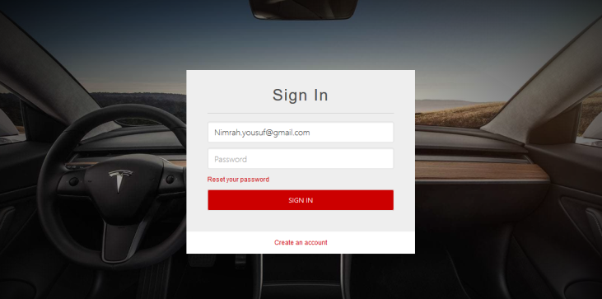

2- CART

**Add to Cart** is a way to create a temporary list of items by adding them to your **cart**, which will keep track of the items.

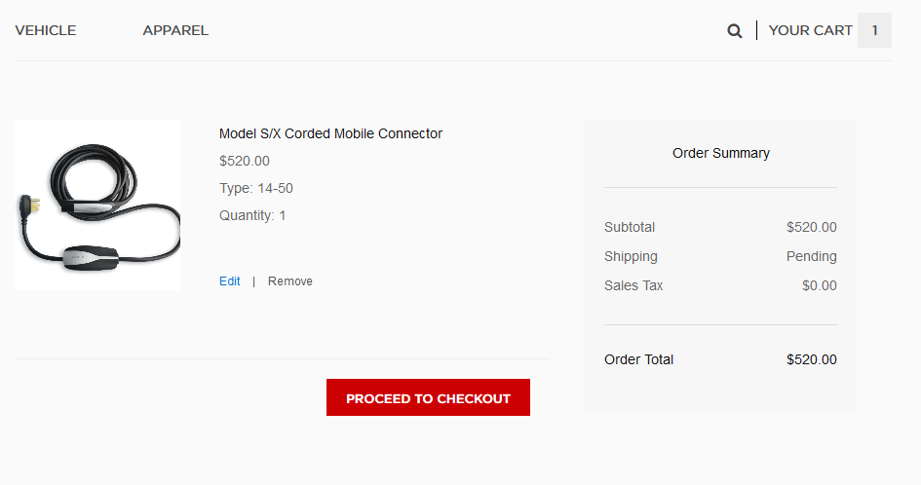

3- Payment

In this system we are dealing the **mode of payment** by Cash. You can pay online through PayPal, debit cards, credit cards or cash on delivery. You can lease or loan your car too.

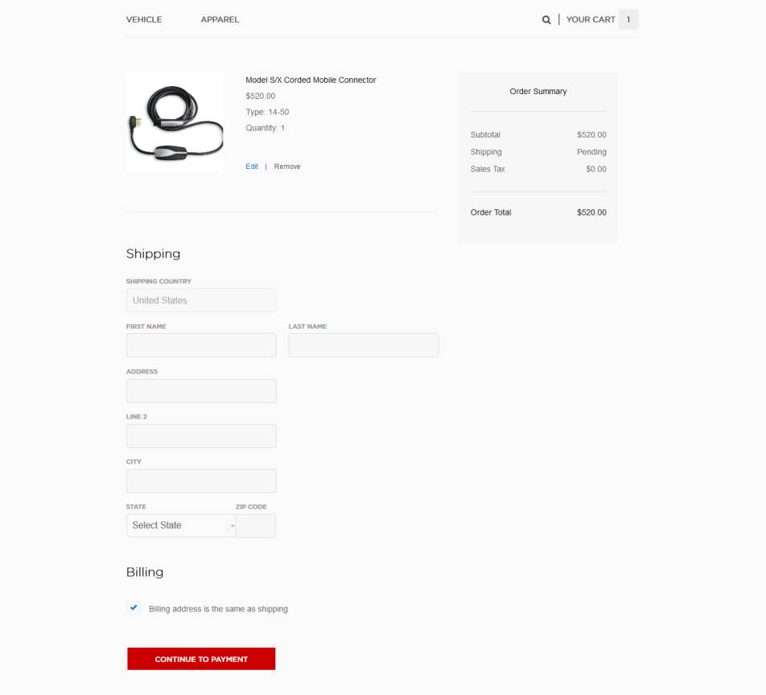

4- Design Studio

You can customize your car here with your desirable features and purchase it.

5- Test Drive

A test drive is the **driving of an automobile** to assess its drivability, or roadworthiness, and general operating state. You can request a test drive online for appointment

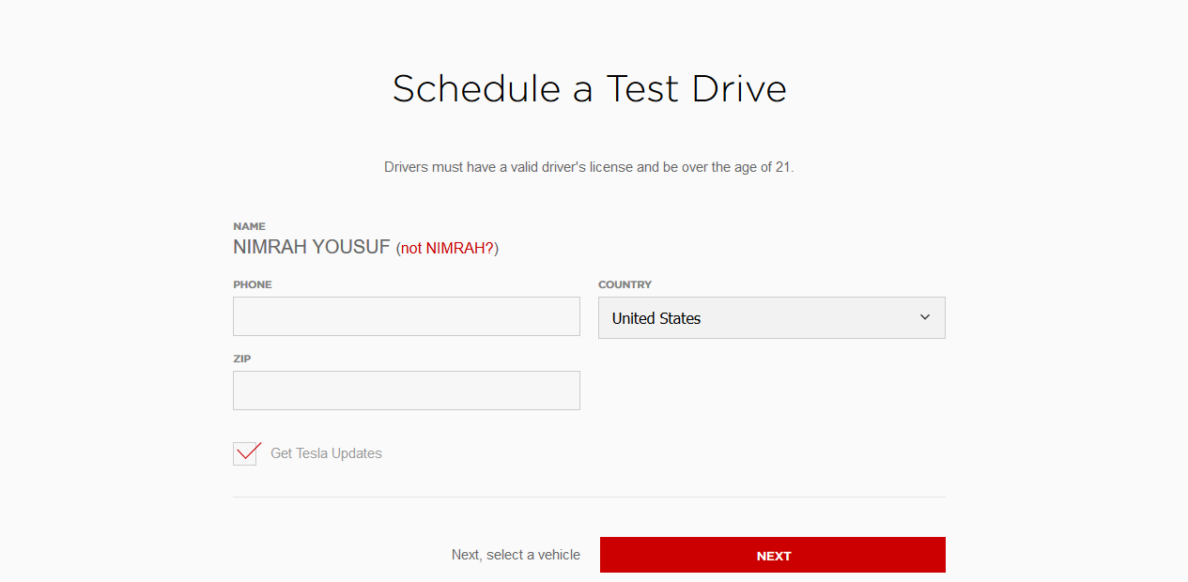

# NON-FUNCTIONAL REQUIREMENTS

Following Non-functional requirements will be there in the Insurance on internet:

* Security
* Reliability
* Maintainability
* Portability
* Reusability
* Application Affinity/Compatibility

# 1.6 WORK BREAKDOWN STRUCTURE (WBS)

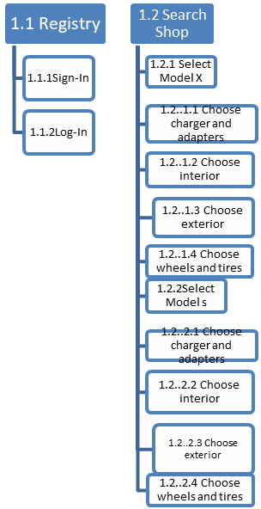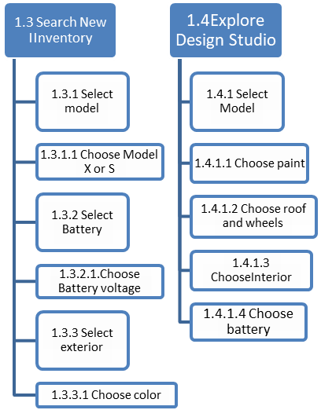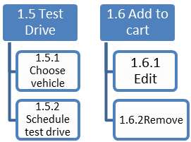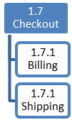

|  |  |  |  |  |  |  |  |
| --- | --- | --- | --- | --- | --- | --- | --- |
| Activities | ID | | Predecessor | | Duration | Early Start | Early Finish |
| Search Shop | | A | | - | 2d | 0 | 1 |
| Select Model | | B | | A | 1d | 1 | 3 |
| Model X | | C | | B | 1d | 3 | 6 |
| Model S | | D | | B | 1d | 3 | 4 |
| Select Chargers and adapters | | E | | C,D | 2d | 6 | 10 |
| Select Interior | | F | | C,D | 2d | 6 | 8 |
| Select Exterior | | G | | C,D | 3d | 6 | 9 |
| Select Wheels and tires | | H | | C,D | 1d | 6 | 10 |
| Add to cart | | I | | E,F,G,H | 3d | 10 | 15 |
| Checkout | | J | | Q,I | 1d | 20 | 26 |
| Build your own | | K | | - | 7d | 0 | 5 |
| Design Studio | | L | | K | 7d | 5 | 11 |
| Choose Paint | | M | | L | 1d | 11 | 12 |
| Choose Roof and wheels | | N | | L | 1d | 11 | 13 |
| Choose Interior | | O | | L | 1d | 11 | 14 |
| Choose Battery | | P | | L | 1d | 11 | 15 |
| Save design | | Q | | M,N,O,P | 3d | 15 | 20 |
| Test drive | | R | | - | 1d | 0 | 1 |
| Schedule Test Drive | | S | | R | 2d | 1 | 3 |
| Select Vehicle | | T | | R | 2d | 1 | 4 |

# 1.7 ACTIVITY GRAPH

END

K(3d)

L(3d)

P(1d)

O(1d)

N(1d)

M(1d)

A(2d)

B(1d)

C(1d)

D(1d)



G(3d)

E(2d)

F(2d)

H(1d)

I(3d)

J(1d)

Q(3d)

START

R(1d)

T(2d)

S(2d)

# 1.8 CRITICAL PATH

A+B+C+E+I+J = 1+2+3+4+5+6 = 21

A+B+C+F+I+J=1+2+3+2+5+6 =19

A+B+C+G+I+J=1+2+3+3+5+6=20

A+B+C+H+I+J=1+2+3+4+5+6=21

A+B+D+E+I+J=1+2+1+4+5+6=19

A+B+D+F+I+J=1+2+1+2+5+6=17

A+B+D+G+I+J=1+2+1+3+5+6=18

A+B+D+H+I+J=1+2+1+4+5+6=19

K+L+M+Q+J=5+6+1+5+6=23

K+L+N+Q+J5+6+2+5+6=24

K+L+O+Q+J=5+6+3+5+6=25

K+L+P+Q+J=5+6+4+5+6=26 Critical Path

R+S+J=1+2+6=9

R+T+J=1+3+6=10

|  |  |  |
| --- | --- | --- |
| 3 | C | 6 |
| 5 |  |  |
| 8 | 3 | 11 |

|  |  |  |
| --- | --- | --- |
| 6 | E | 10 |
| 5 |  |  |
| 11 | 4 | 15 |

|  |  |  |
| --- | --- | --- |
| 6 | F | 8 |
| 7 |  |  |
| 13 | 2 | 15 |

|  |  |  |
| --- | --- | --- |
|  | A |  |
|  |  |  |
|  |  |  |

|  |  |  |
| --- | --- | --- |
| 1 | B | 3 |
| 5 |  |  |
| 6 | 2 | 8 |

|  |  |  |
| --- | --- | --- |
| 3 | D | 4 |
| 7 |  |  |
| 10 | 1 | 11 |

|  |  |  |
| --- | --- | --- |
| 6 | G | 9 |
| 6 |  |  |
| 12 | 3 | 15 |

|  |  |  |
| --- | --- | --- |
| 6 | H | 10 |
| 5 |  |  |
| 11 | 4 | 15 |

|  |  |  |
| --- | --- | --- |
| 10 | I | 15 |
| 5 |  |  |
| 15 | 5 | 20 |

|  |  |  |
| --- | --- | --- |
| 0 | A | 1 |
| 5 |  |  |
| 5 | 1 | 6 |

|  |  |  |
| --- | --- | --- |
| 20 | J | 26 |
| 0 |  |  |
| 20 | 6 | 26 |

|  |  |  |
| --- | --- | --- |
| 0 | K | 5 |
| 0 |  |  |
| 0 | 5 | 5 |

|  |  |  |
| --- | --- | --- |
| 5 | L | 11 |
| 0 |  |  |
| 5 | 6 | 11 |

|  |  |  |
| --- | --- | --- |
| 11 | M | 12 |
| 3 |  |  |
| 14 | 1 | 15 |

|  |  |  |
| --- | --- | --- |
| 11 | N | 13 |
| 2 |  |  |
| 13 | 2 | 15 |

|  |  |  |
| --- | --- | --- |
| 1 | T | 4 |
| 6 |  |  |
| 7 | 3 | 20 |

|  |  |  |
| --- | --- | --- |
| 0 | R | 1 |
| 16 |  |  |
| 16 | 1 | 17 |

|  |  |  |
| --- | --- | --- |
| 11 | O | 14 |
| 1 |  |  |
| 12 | 3 | 15 |

|  |  |  |
| --- | --- | --- |
| 11 | P | 15 |
| 0 |  |  |
| 11 | 4 | 15 |

|  |  |  |
| --- | --- | --- |
| 1 | S | 3 |
| 17 |  |  |
| 18 | 2 | 20 |

|  |  |  |
| --- | --- | --- |
| 15 | Q | 20 |
| 0 |  |  |
| 15 | 5 | 20 |

# 1.9 GANTT CHART

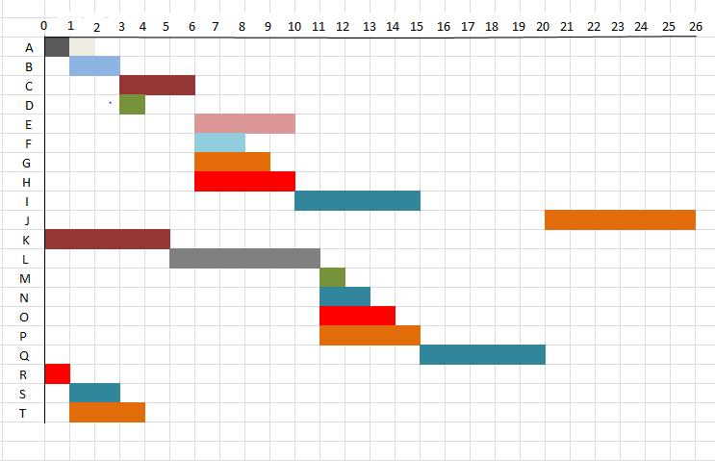

# 1.10 CONTEXT LEVEL DATA FLOW DIAGRAM

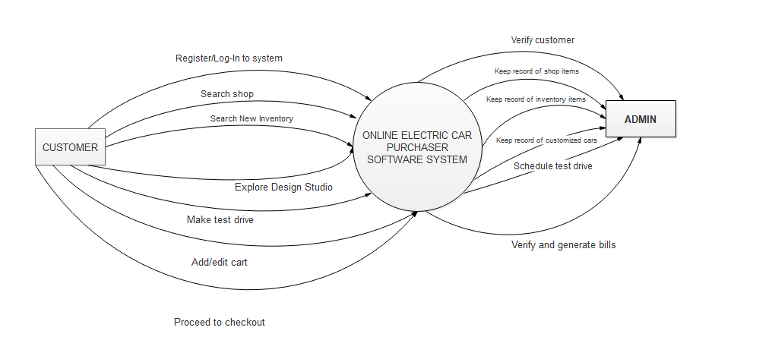

# 

# 01.11 DATA FLOW DIAGRAM

**PAYMENT SERVICE**

Update data

Update data

Generate bill

Ask for bill

View cart

Add item to cart

Confirm/reject Appointment

Set Appointment

Confirmation status

Make Appointment

Save your Design

Update

Select Model

Retrieve data

Retrieve data

Select Model

Confirmation

Select model/interior/exterior/battery/wheels

Confirmation

Verification

Update data

Get data

Request for log-in

**Checkout**

**Search Shop**

**Search New Inventory**

**Explore Design Studio**

**Test Drive**

**Cart**

Order Detail

Cart Detail

Test Drives data

Customized cars

Data

New Inventory Data

Models Data

Registered Users

**ADMIN**

**CUSTOMER**

Proceed to checkout

Order for item

# 

# 1.12 ERD

**Remove**

**Edit**

**Account id**

**Address**

**Name**

**Cart**

**Adds to**

**Credit card**

**PayPal**

**CashOnDelivery**

**BILL**

**Appointment**

**Vehicle**

**Interior**

**Wheels**

**Paint**

**Battery**

**Exterior**

**Model**

**Color**

ERD

**Log-in**

**Register**

**Generates**

**TEST DRIVE**

**DESIGN STUDIO**

**NEW INVENTORY**

**Offers**

**SYSTEM**

**CUSTOMER**

**URL**

**Name**

# 1.13 USE CASE DIAGRAM

Payment Service

Admin

**Customer**

<<Extend>>

<<Extend>>

<<Extend>>

<<Include>>

<<Include>>

<<Include>>

<<Include>>

<<Include>>

**Make Appointments**

**Generate Receipts**

**Customer Data**

Extension Point

**Search New**

**Inventory**

Extension Point

**Search Shop**

**Design Studio**

**Test Drive**

**Checkout**

**Save Design**

<<Include>>

<<Include>>

<<Include>>

<<Extend>>

<<Extend>>

<<Extend>>

<<Extend>>

<<Include>>

<<Include>>

**Add to cart**

**Add to cart**

**Billing**

Extension point

# 

# 1.14 SYSTEM SEQUENCE DIAGRAM

System Sequence Diagram

LOOP

AddToCart()

TestDriveSchedule()

Logout()

Confirmed bill

Payment(amount)

Decided

Confirmation

Confirmed

OptionSelected()

Car options

Authentication

LogIn()

**Customer**

**System**

**(Website)**

# 1.15 SEQUENCE DIAGRAM 1

**CUSTOMER**

**SEARCH SHOP**

**TEST DRIVE**

**BILL**

**ACCOUNT**

Sequence Diagram 1

LOOP

logout()

Confirmed Bill

BillingInfo()

Payment(amount)

Confirmation

ScheduleTestDrive()

AddTocart()

Searchcar()

Confirmation

Search results

Authentication

LogIn()

# 1.16 SEQUENCE DIAGRAM 2

**CUSTOMER**

**SEARCH NEW INVENTORY**

**TEST DRIVE**

**BILL**

**ACCOUNT**

LOOP

logout()

Confirmed Bill

Payment(amount)

Authentication

LogIn()

Sequence Diagram 2

Confirmation

ScheduleTestDrive()

AddTocart()

Confirmation

BillingInfo()

Confirmed

SelectExterior()

Confirmed

SelectInterior()

Model confirmed

SelectModel()

# 1.17 SEQUENCE DIAGRAM 3

**CUSTOMER**

**DESIGN STUDIO**

**TEST DRIVE**

**BILL**

**ACCOUNT**

LOOP

logout()

Authentication

LogIn()

Confirmed

Confirmed

ChoosePaint()

Sequence Diagram 3

Confirmed

ChooseBattery()

AddTocart()

Confirmation

ScheduleTestDrive()

Confirmation

BillingInfo()

Payment(amount)

Confirmed Bill

ChooseWheels/Tyres()

Model confirmed

ChooseModel()

# 1.18 CLASS DIAGRAM

1

0..*

1

0..*

0..*

0…*

0…*

1

1

1

Order details

**-order id:** int

**-Product id:** int

**-product name:** string

**-quantity**: int

**-unit cost:** float

**-sub total:** float

+calcprice ( )

**Shipping info**

**-shipping id :** int

-**shipping type:** string

-**shipping cost**: int

**-Shipping region id**: int

+updateshipinginfo()

**Orders**

**-order id :** int

-**date created :** string

**-date shippes :** string

**-customer name :** string

-**customer id :** string

-**status :** string

-**shipping id :** string

+placeorder ( )

**Shopping cart**

**- cart id :** int

**- car id :** int

- **quantity :** int

**- date added :** int

+addcartitem ( )

+update quantity ( )

+viewcartdetails ( )

+checkout ( )

**Admin**

**- management :** string

- **email** : string

+ updatecatalog ( ): bool

**Cars**

**- Car id :** int

**- car name :** string

**- car model :** string

+ viewcars ( )

**Customer**

**- name :** string

**- address:** string

**- email:** string

**- credit card info :**string

**- Shipping info:** string

+ reginfo ()

+ Login ()

+ updateprofil( )

+ verifylogin( ): bool

**User**

**- user id :** string

**- password :** string

**- login status :** string

# 

# 1.19 ACTIVITY DIAGRAM

Shipping order

Via cash

Via credit card

Payment

Schedule test drive

Confirm order

Search car

Search available

Search new inventory

Design your own

View car

Add to shopping cart

Activity Diagram

Receive order

View shopping cart

Edit shopping cart

Receive order

Receive order

Receive order

# 1.20TEST CASES